**Microprocessor and Computer Architecture**

**UE20CS252**

**Assignment**

**Date: 18/03/2022**

**Name: Vishwa Mehul Mehta**

**SRN: PES2UG20CS389**

**Section: F**

1. Write a program in ARM7TDMI-ISA to search for an element in an array. Display appropriate messages on the standard output device. For Successful search display as “Successful Search” and if the search is unsuccessful, display as “Unsuccessful Search”. Use Binary search Technique.

Code:

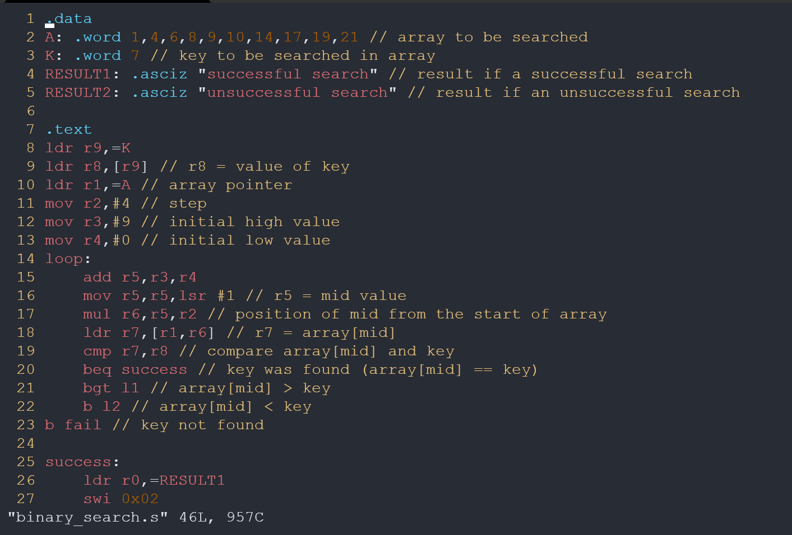

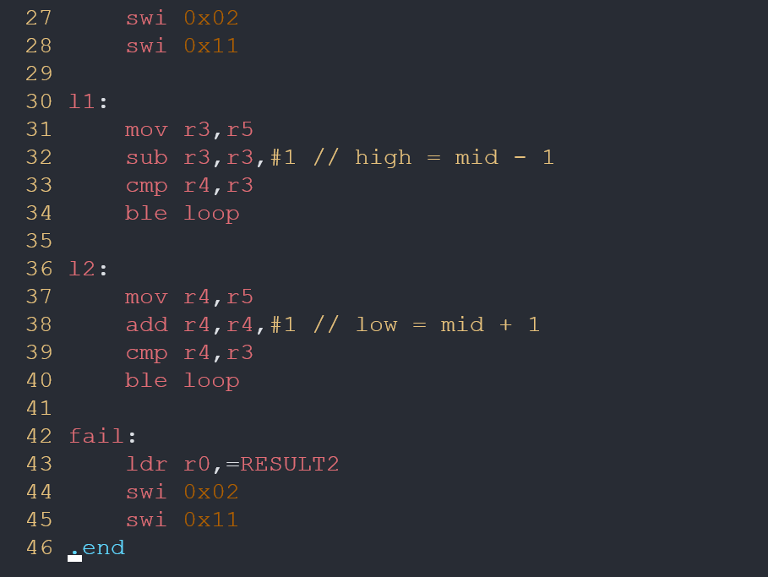

Output:

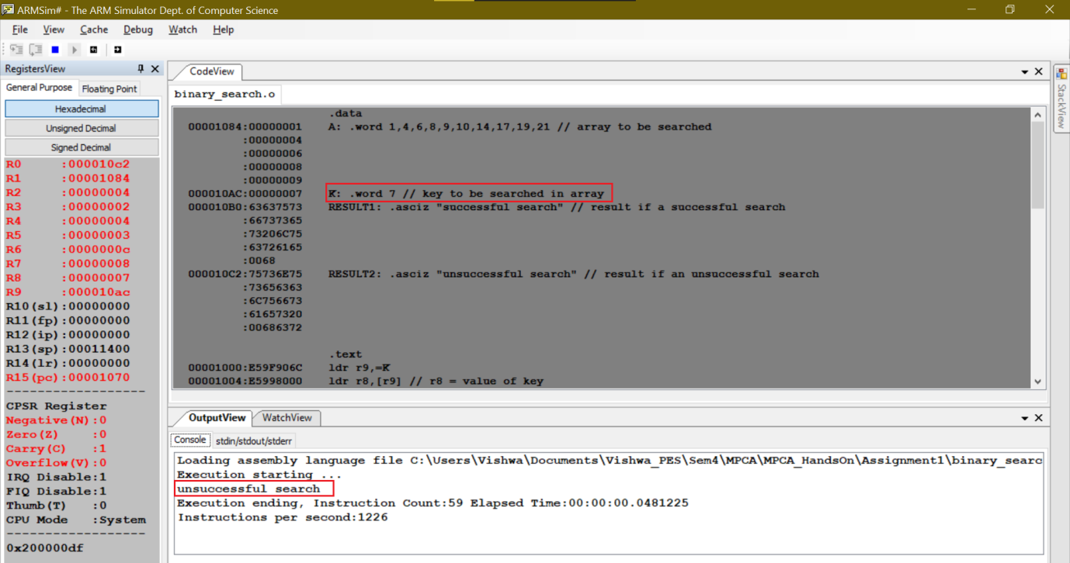

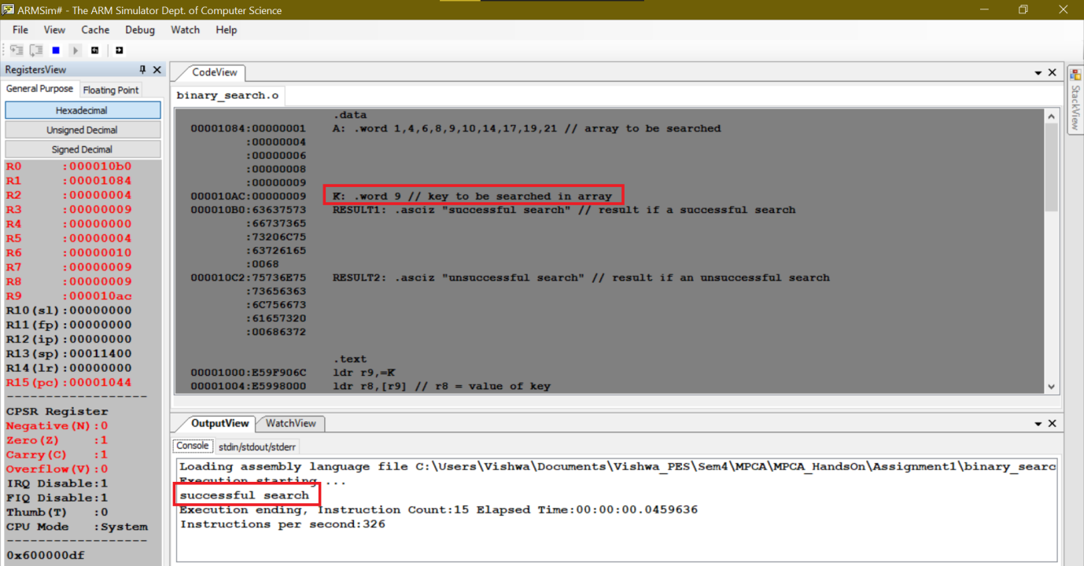

2. Write a program in ARM7TDMI-ISA to find a sub string in a given main string.

Example1: Main string : My name is Bond.

Character : ‘name’.

**Expected Output : “String Present”**

Example2: Main string : My name is Bond.

Character : ‘James’.

**Expected Output : “String Absent”**

Code:

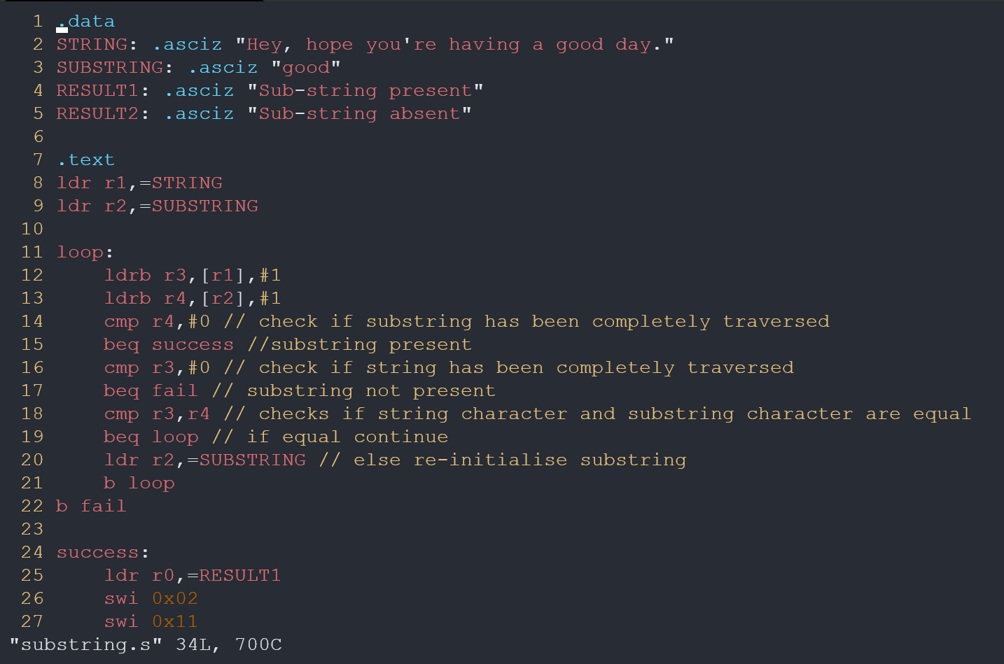

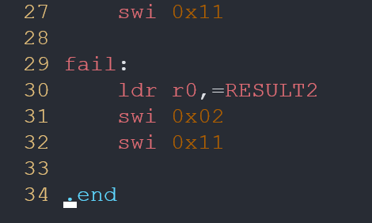

Output:

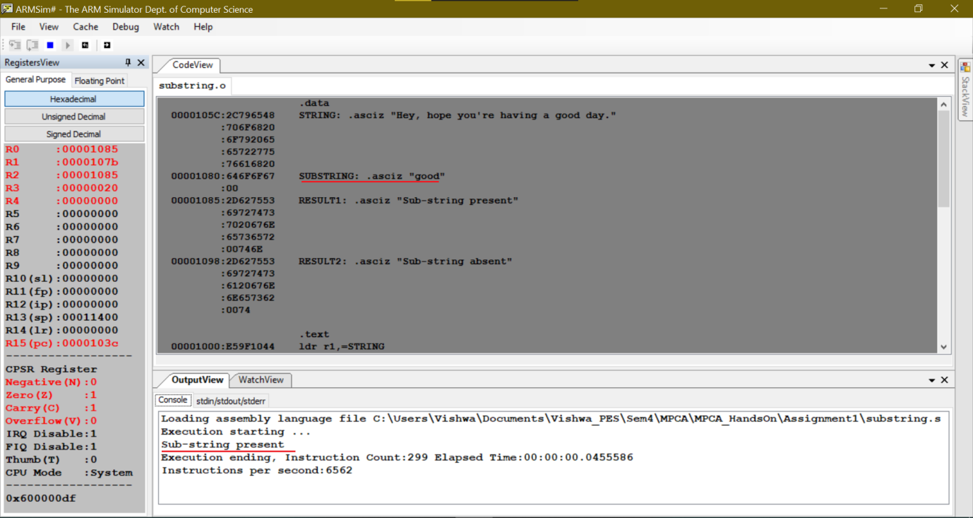

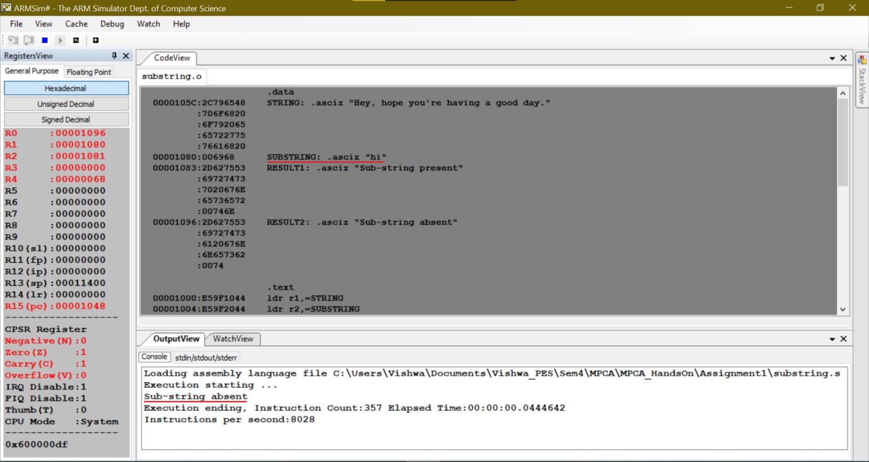

3. Consider the following sequence of instructions in MIPS architecture.

LDR R1, [R2, #40]

ADD R2, R3, R3

ADD R1, R1, R2

STR R1, [R2, #20]

a. Find all dependencies in this instruction sequence.

b. Find all hazards in this instruction sequence for a five stage pipeline with and without data forwarding.

c. Find whether NOPs are required to be introduced inspite of data forwarding in this instruction sequence.

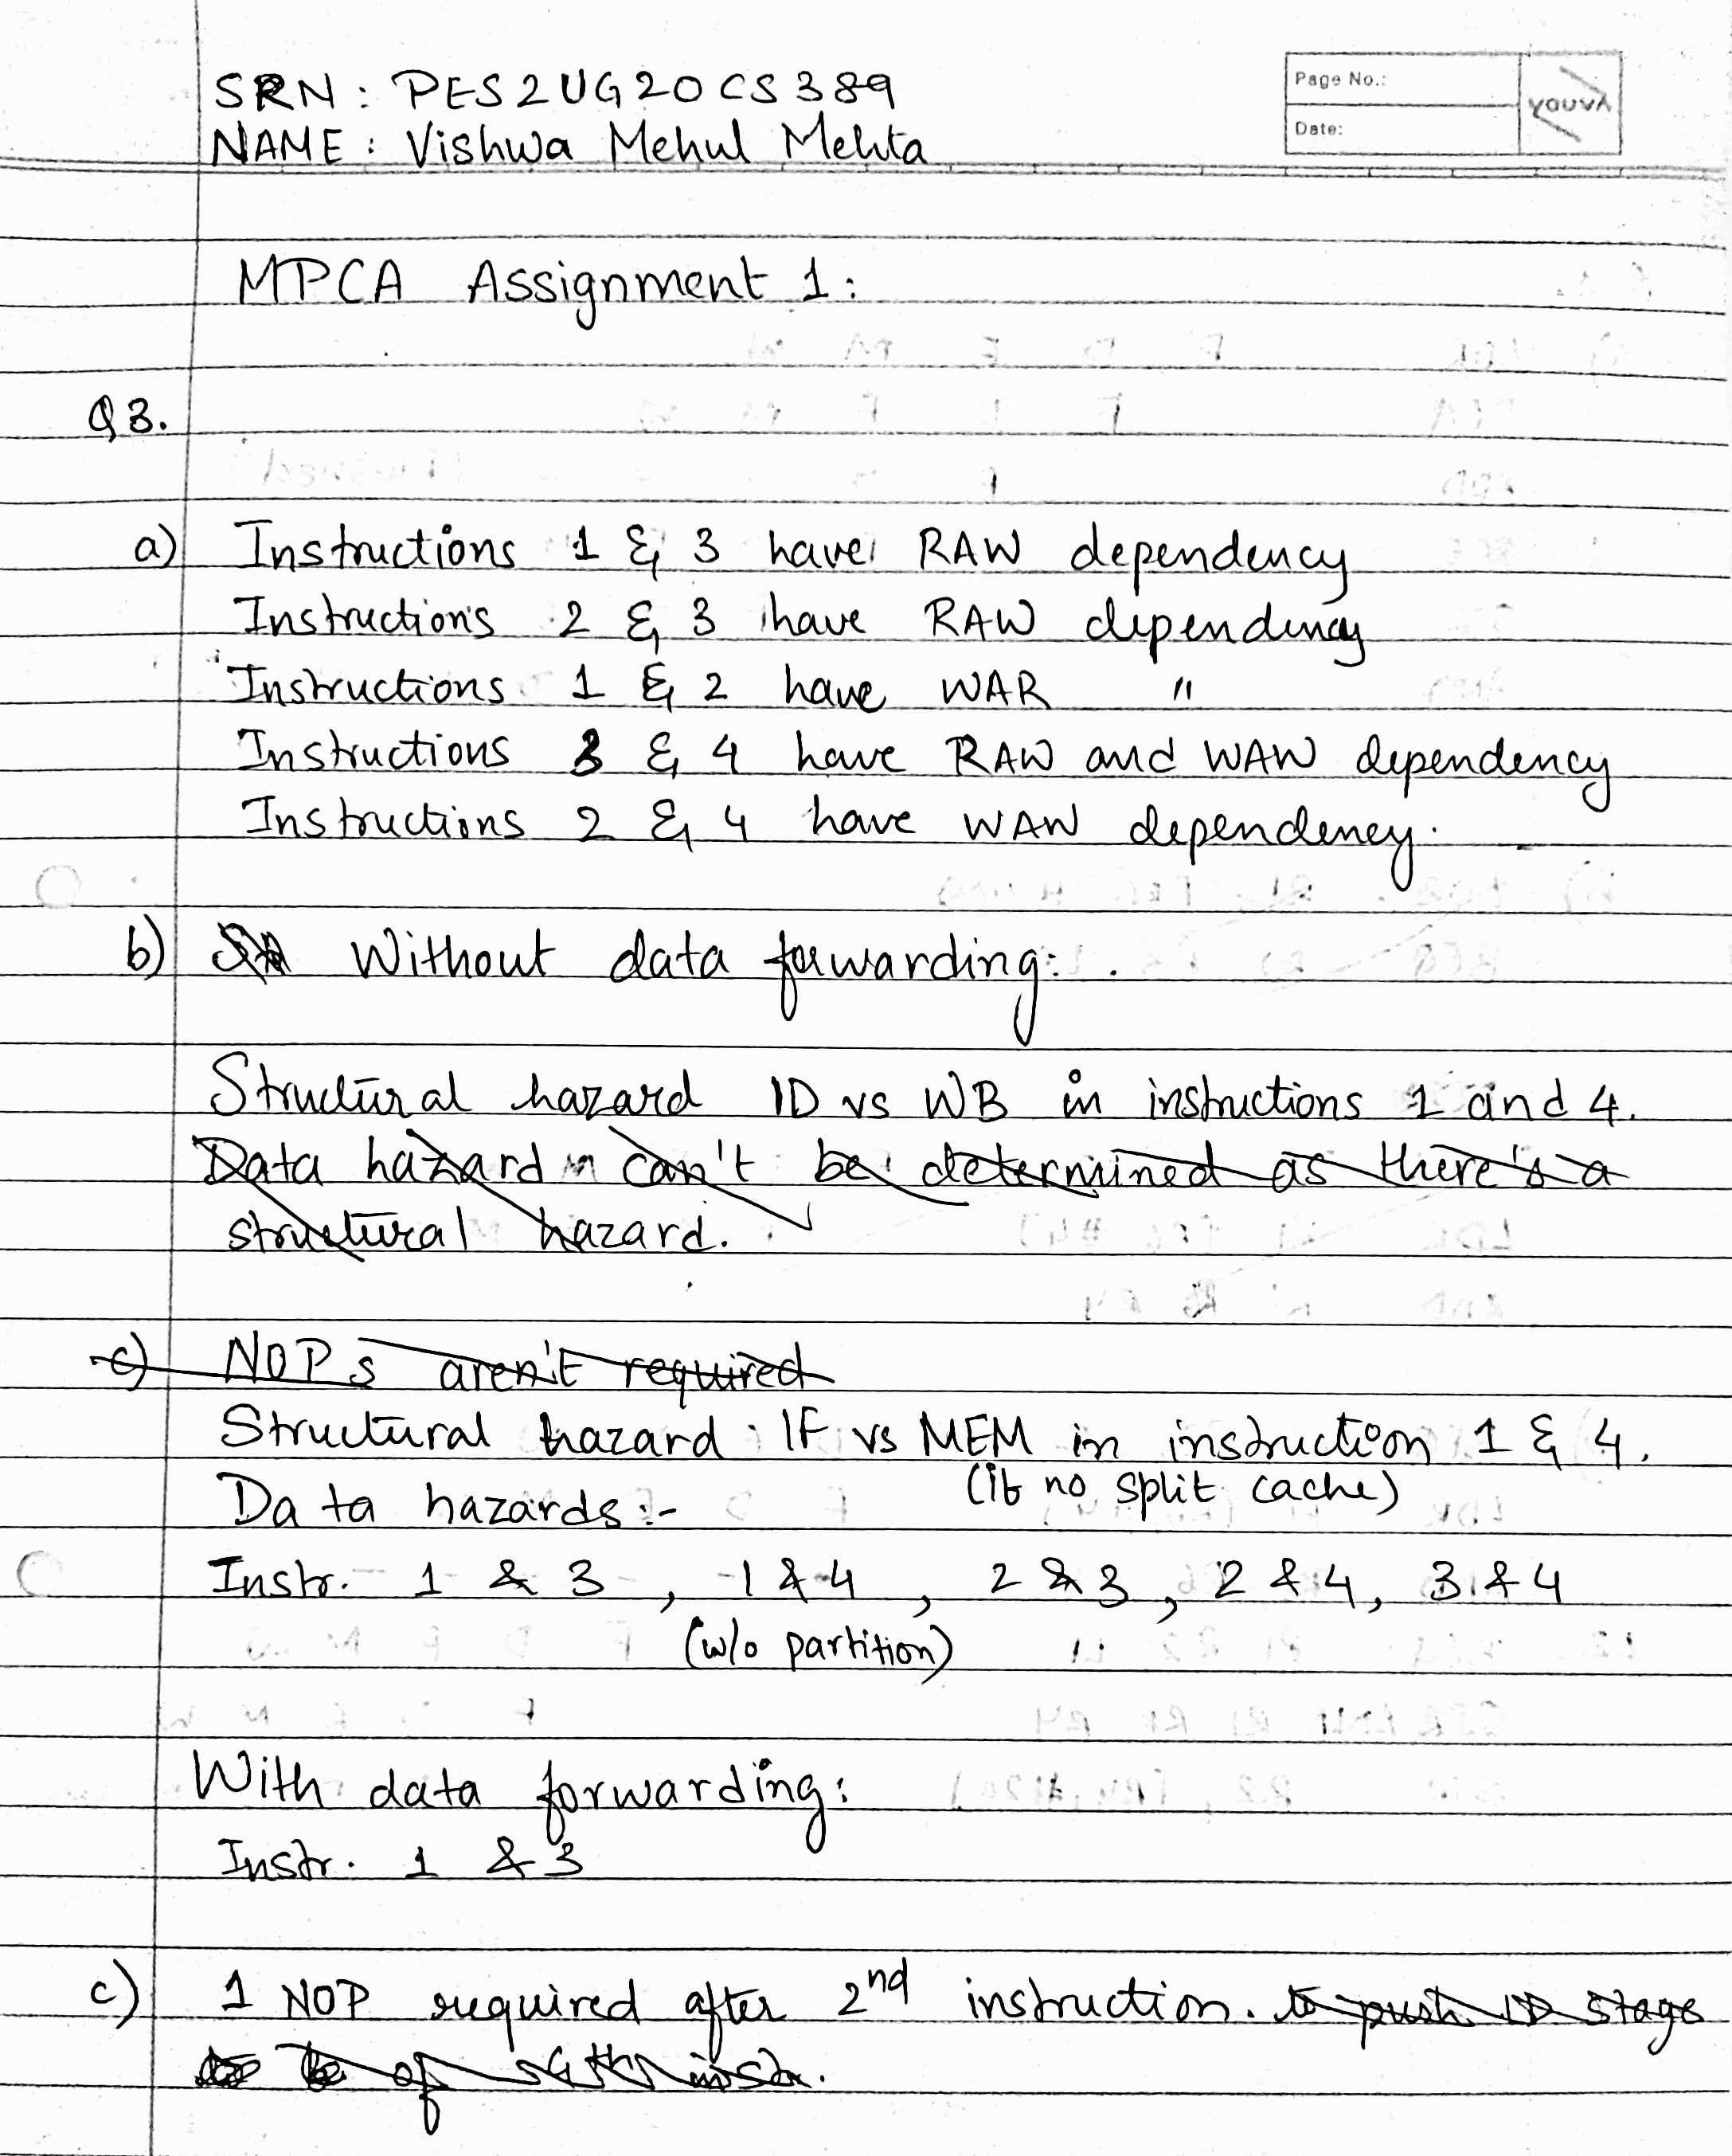

4. Consider the following sequence of instructions in MIPS architecture.

LDR R1, [R6,#40]

BEQ R2, R3, LABEL2 ; BRANCH TAKEN

ADD R1, R6, R4

LABEL2: BEQ R1,R2, LABEL1 ; BRANCH NOT TAKEN

STR R2,[R4, #20]

AND R1, R1, R4

a. Draw the pipeline execution diagram for this code, assuming there are no delay slots and that branches execute in the EX stage.

b. Repeat the exercise mentioned in a and draw the pipeline execution diagram for this code, assuming that delay slots are used by writing a “SAFE INSTRUCTION” in the delay slot.

